Computer Language Coding Concepts

New & Annul in a Diagram
The concept of New & Annul is explained in the article New & Annul. The current article demonstrates their expression in a diagram.

The system members New, Anull, Created . Get and Created . Set are part of the system interface of a related item or a related list item and displayed in a diagram as follows:

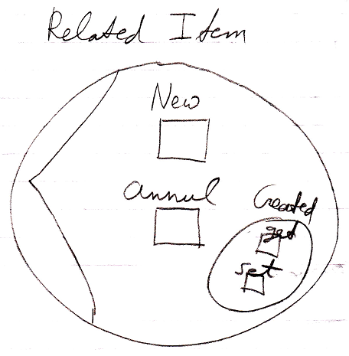

See also: System Objects, New & Annul

Author & Copyright: Jan-Joost van Zon Date: July 18, 2008 – July 18, 2008 Location: Oosterhout, The Netherlands Status: Finished

